**Automation Test Environment setup in TFS**

Document Status: Draft

Updated On: April 21, 2016

Document Classification: Internal

Version 1.0

**Prepared by:**

Kanimozhi Vellaisamy

**Contributors:**

Cygan, Krzysztof Ryszard

Pundarikeshvan, Sujeethra

This document is to articulate the step by step instructions to setup automation testing environment in TFS.

Note: These steps are for the configurations, Visual Studio 2013 with Windows OS in general.

1. **Configure Test Controller**

**General Note:** Test Controllers are registered to TFS project collections. Test Agents in any projects in the collection can use this Controller. One Test controller can be used by multiple Test Agents

**Precondition:**

1. User should have admin access to the machine that has to be configured as ‘Test Controller’ and Visual Studio 2013 installed
2. Either user should be added as a ‘Service Account’ in TFS collection or should have the FID or Service account that is added to TFS collection handy.
3. User should be logged in to the desired machine as administrator.

**Steps to Configure:**

* 1. Go to ‘Windows Start Menu’ -> All Programs - > Visual Studio 2013
  2. Right click ‘Test Controller Configuration Tool’ -> ‘Run as administrator’

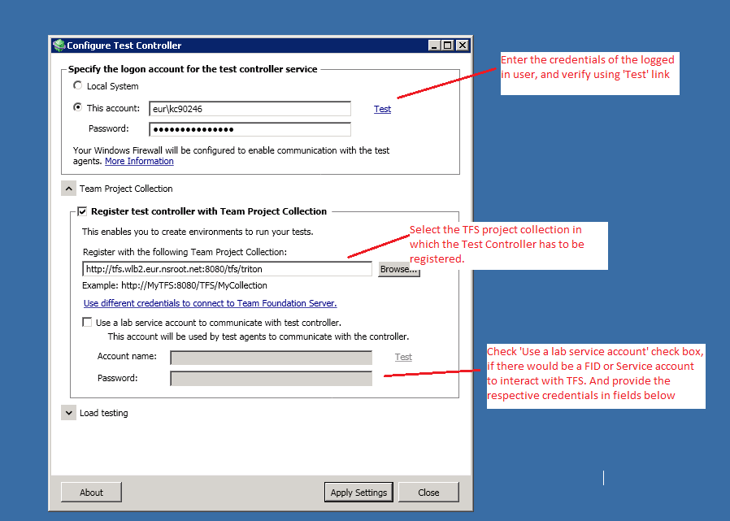

Click ‘Apply Settings’.

This will validate and show the progress in configuration. It would take few minutes to complete the setup.

**Confirm setup completion:**

1. The below highlighted service should be in ‘Started’ state in the machine.



1. The controller should be listed with ‘Ready’ state in MTM.

Open MTM -> ‘Lab Center’ -> ‘Controllers’

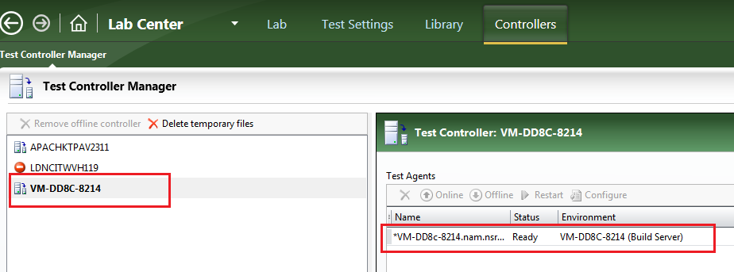

1. **Configure Test Agent**

**General Note**: Test Agents are setup only for a particular project. A machine can be setup as test agent for only one project at a time. The test agent can be configured to use any test controller in the collection. Test Agent will be the machine where the automation tests will be running. All required setup or configurations for test runs should be made in Test Agents.

**Precondition**:

User should have the admin access to the machine while making this configuration

User should have access to TFS and should have Visual Studio 2013 installed.

**Steps to Configure:**

* 1. Go to ‘Windows Start Menu’ -> All Programs - > Visual Studio 2013
  2. Right click ‘Microsoft Test Manager 2013’ -> ‘Run as administrator’
  3. Go to ‘Lab Center’ -> ‘Lab’ -> ‘Environments’ – ‘New’
  4. In Type and Name

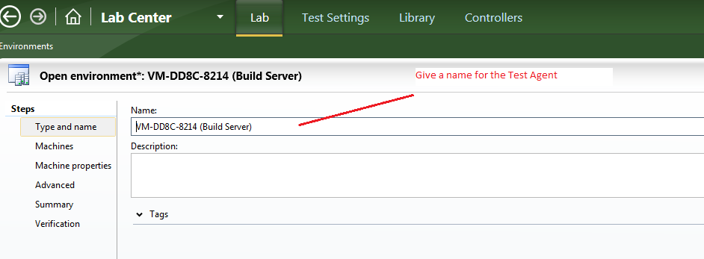

* 1. In ‘Machines’

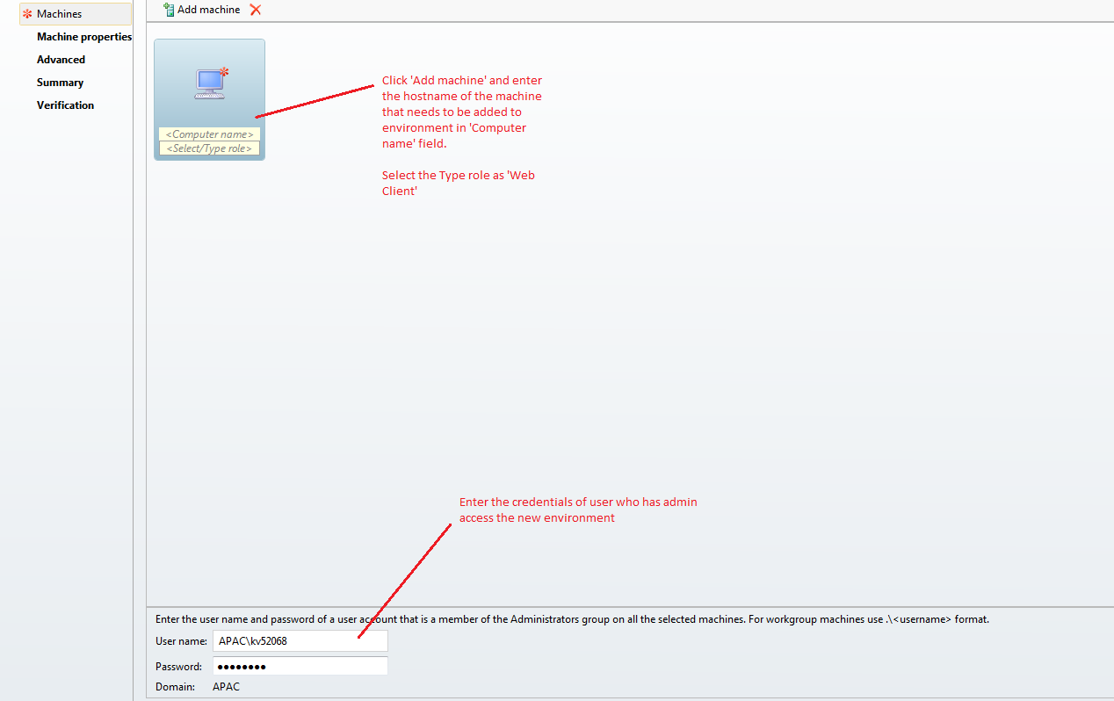

In ‘Advanced’

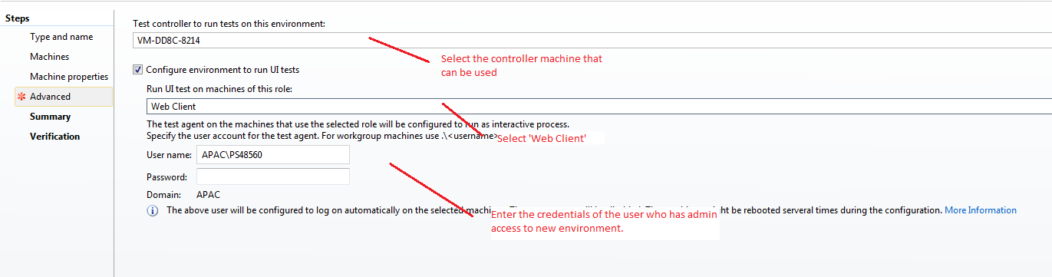

In ‘Verification’ section, Click ‘Verify’ button. Once the verification is done successfully, click ‘Finish’ button.

Post the above step, it will take some time for configuration and automatic machine restart will happen for the new environment.

**To confirm configuration**:

1. The below highlighted service should be in ‘Started’ state in the new environment machine.



1. The Test Agent (Environment) should be listed with ‘Ready’ state in MTM.

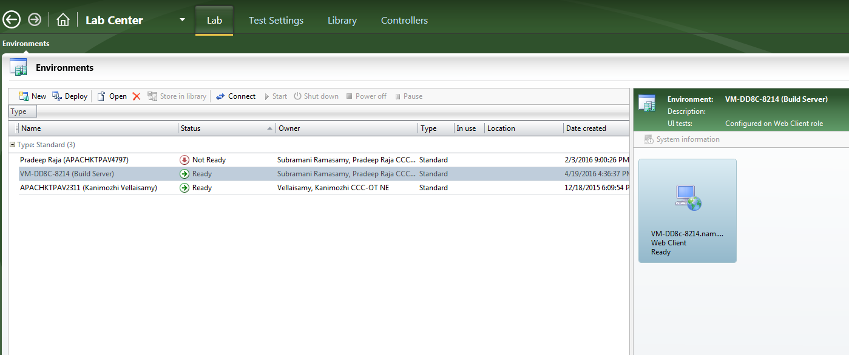

1. ‘Test Agent Window’ should be open in shows in ‘Online’ status in the new environment as shown below.

